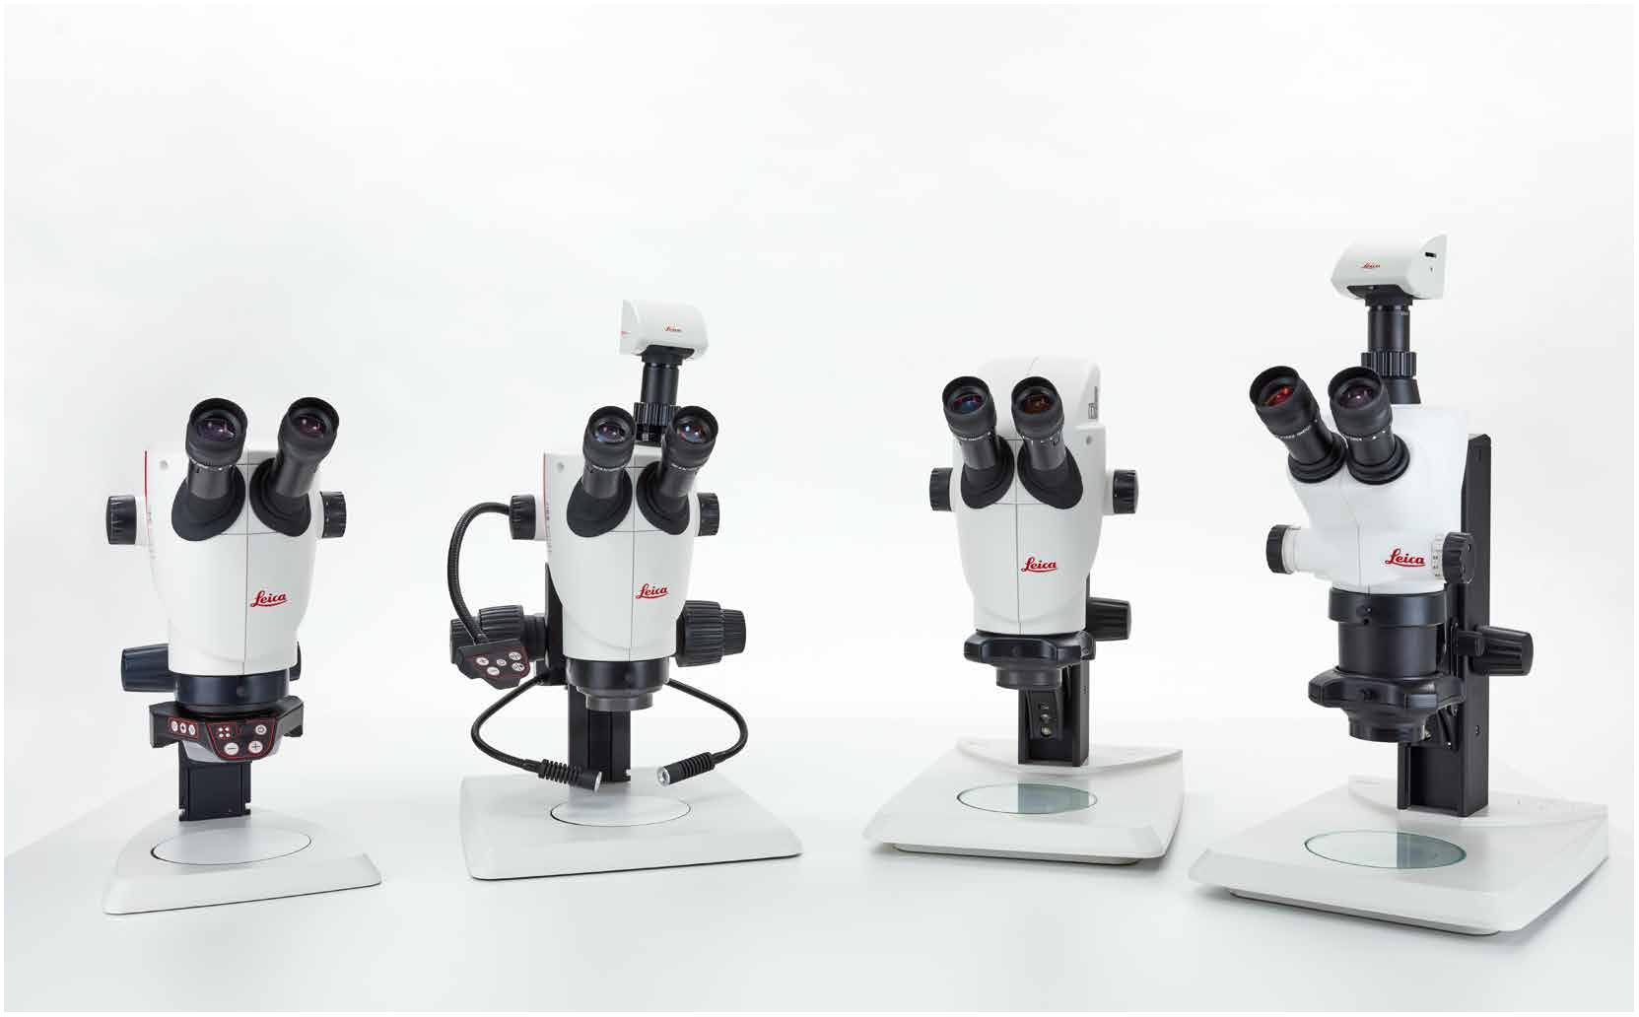

Leica S Series
User Manual

Safety concept
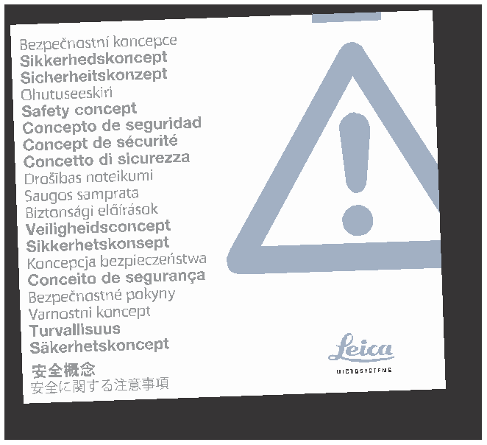Before using your stereo microscope for the first time, please read the "Safety Concept" booklet included with your instrument. It contains additional information about handling and care.
About cleaning
O Do not use any unsuitable cleaning agents, chemicals or techniques for cleaning.

O Never use chemicals to clean colored surfaces or accessories with rubberized parts. This could damage the surfaces, and specimens could be contaminated by abraded particles.
Servicing

Responsibilities of person in charge of instrument
O Ensure that the Leica stereo microscope is operated, maintained and repaired by authorized and trained personnel only.

User manual
User manuals and updates are available for you to download and print from our website www.leica-microsystems.com. Keep it in a safe place, and readily accessible to the user.

This user manual describes the special functions of the Leica stereo microscopes (S series) and contains important instructions for their operational safety, maintenance, and accessories.

The "Safety Concept" booklet contains additional safety information regarding the service work, requirements and the handling of the stereo microscope, accessories and electrical accessories as well as general safety instructions.
You can combine individual system articles with articles from external suppliers (e.g. cold light sources, etc.). Please read the user manual and the safety requirements of the supplier.

Before installing, operating or using the instruments, read the user manuals listed above. In particular, please observe all safety instructions.

To maintain the unit in its original condition and to ensure safe operation, the user must follow the instructions and warnings contained in these user manuals.

Warning of a danger
This symbol indicates especially important information that is mandatory
to read and observe.

Failure to comply can cause the following:
O Hazards to personnel

O Functional disturbances or damaged instruments

Warning of hazardous electrical voltage
This symbol indicates especially important information that is
mandatory to read and observe.

Failure to comply can cause the following:
O Hazards to personnel

O Functional disturbances or damaged instruments
Danger due to hot surface
This symbol warns against touching hot surfaces, e.g. those of light bulbs.

Important information
This symbol indicates additional information or explanations that intend
to provide clarity.

Explanatory notes
O This symbol within the text stands for additional information and explanations.

Figures
(1) Numbers in parentheses within the descriptions relate to the figures and the items within those figures.

Description
The individual modules fulfill the highest requirements for observation and documentation of Leica stereo microscopes of the S series.
 | O | Refer to "Safety Concept" booklet | O | The S series stereo microscopes and
Intended use |  |  |  | accessories are operated, maintained
O Refer to "Safety Concept" booklet | O | Electrical components must be placed at |  | and repaired by authorized and trained
 |  | least 10 cm away from the wall and from |  | personnel only.
 |  | flammable substances.
Non-intended use |  |  | O | All operators have read, understood and
O Refer to "Safety Concept" booklet | O | Avoid large temperature fluctuations, |  | observe this User Manual, and particularly
 |  | direct sunlight and vibrations. These |  | the safety instructions.
Never use S series microscopes or their |  | conditions can distort measurements * and
components for surgical procedures (e.g. on |  | micrographic images.
the eye) unless they are specifically intended
for that purpose. | O | In warm and warm-damp climatic zones,
 |  | the individual components require special
The devices and accessories described in this |  | care in order to prevent the build-up of
User Manual have been tested with regard to |  | fungus.
potential hazards. The responsible Leica affiliate
must be consulted whenever the instrument is |  | * Measurement results depend on used
altered, modified or used in conjunction with |  | objective, zoom and microscope settings.
non-Leica components that are outside of the
scope of this manual!

Unauthorized alterations to the instrument or noncompliant use shall void all rights to any warranty claims!

Place of use
Responsibilities of person in charge of instrument
O Refer to "Safety Concept" booklet

Ensure that:

Repairs, service work
O Refer to "Safety Concept" booklet

O Only original Leica Microsystems spare parts may be used.

O Before opening the instruments, switch off the power and unplug the power cable.

Touching the live circuit can cause injury.
Transport
O Use the original packaging for shipping or transporting the individual modules of the Leica S stereo microscopes and the accessory components.

O In order to prevent damage from vibrations, all moving parts that (according to the user manual) can be assembled and disassembled by the customer should be disassembled and packed separately.
Integration in third-party products
O Refer to "Safety Concept" booklet

Disposal
O Refer to "Safety Concept" booklet

Legal regulations
O Refer to "Safety Concept" booklet

EC Declaration of Conformity
O Refer to "Safety Concept" booklet

Health risks
Workplaces with stereo microscopes
• facilitate and improve the viewing task,
but they also impose high demands on the eyes
and holding muscles of the user. Depending on the duration of uninterrupted work, asthenopia and musculoskeletal problems may occur. For this reason, appropriate measures for reduction of the workload must be taken:

O Optimal arrangement of workplace, work assignments and work flow (changing tasks frequently).

O Thorough training of the personnel, giving consideration to ergonomic and organizational aspects.
O The ergonomic optical design and construction of the Leica S stereo microscopes are intended to reduce the exertion of the user to a minimum.

Direct contact with eyepieces is a
• potential transmission method for
bacterial and viral infections of the eye.

The risk can be kept to a minimum by using personal eyepieces for each individual or detachable eyecups.

General Instructions 2
Important Safety Notes 3
Symbols Used 4
Safety Instructions 5
Contents 8

Leica S Series
Congratulations! 11
The Modular Design: Everything is Possible 12
What Your Stereo Microscope has to Offer you 13
Microscopes of the S Series 14
On We Go 15

Assembly
Installing the Basic Equipment (Overview) 17
Focusing Column 18
Sub-base for Transmitted Light and Cold Light Source 19
Optics Carrier and Additional Objective 20
Available Graticules 21
Inserting Graticules 22
Eyepieces 23
Leica LED Illumination 24
Camera Design (Leica S9 D and S APO) 25
Quick Start Guide
An Overview of a S Series Stereo Microscope 27
Using the Eyepieces 28
The Correct Interpupillary Distance 29
Focusing 30
Changing Magnification (Zooming) 31
Limiting Zoom Range 32
Regulating the Resistance of the Focusing Drive 34
Changing the Position of the Optics Carrier 35
Diopter Settings and Parfocality: 1 Adjustable & 1 Fixed Eyepiece 36
Dioptric Correction With two Adjustable Eyepieces 39
Connectivity of the S9 i Stereo Microscope With Integrated Camera 42
The S9 i With Integrated Camera 43
S9 i: Overview 44

Get Set!
USB Mode – Capturing and Adjusting Images Using a Computer 46
HDMI Mode – Capturing Images Without a Computer or Without a Wireless
Device 48
Adjusting Settings While in SD Mode 50
Ethernet Mode – Capturing and Adjusting Images Using a Network 51

Extend!
How to Install the Coded Zoom 53
Installation of the Coded Zoom in LAS X 55

The Camera Remote Control
Optional Remote Control 58
Viewing Images and Movies With the Optional Remote Control 59
Calling up the Camera Menu 60
COLOR (Automatic White Balance) 61
COLOR (Manual White Balance) 62
EXPOSURE 63
RESOLUTION 64
SETUP CAMERA (Camera Settings) 65
Dimensional Drawings in mm
Leica S9 E With Incident Light and Transmitted Light Illumination 74
Leica S9 D With Incident Light and Transmitted Light Illumination 75
Leica S9 i With Incident Light and Transmitted Light Illumination 76
Leica S APO With Incident Light and Transmitted Light Illumination 77

Technical Data
Technical Data 79

Appendix
Calculating the Total Magnification/Field of View Diameter 81
Troubleshooting 82
Contact Persons, Care, Maintenance, Transport 83
SETUP USER | 66
SETUP ETHERNET | 67
Pairing Cameras With Remotes | 69

Photography & Video
Photography & Video 71
Photography With the Leica S9 D and S APO 72
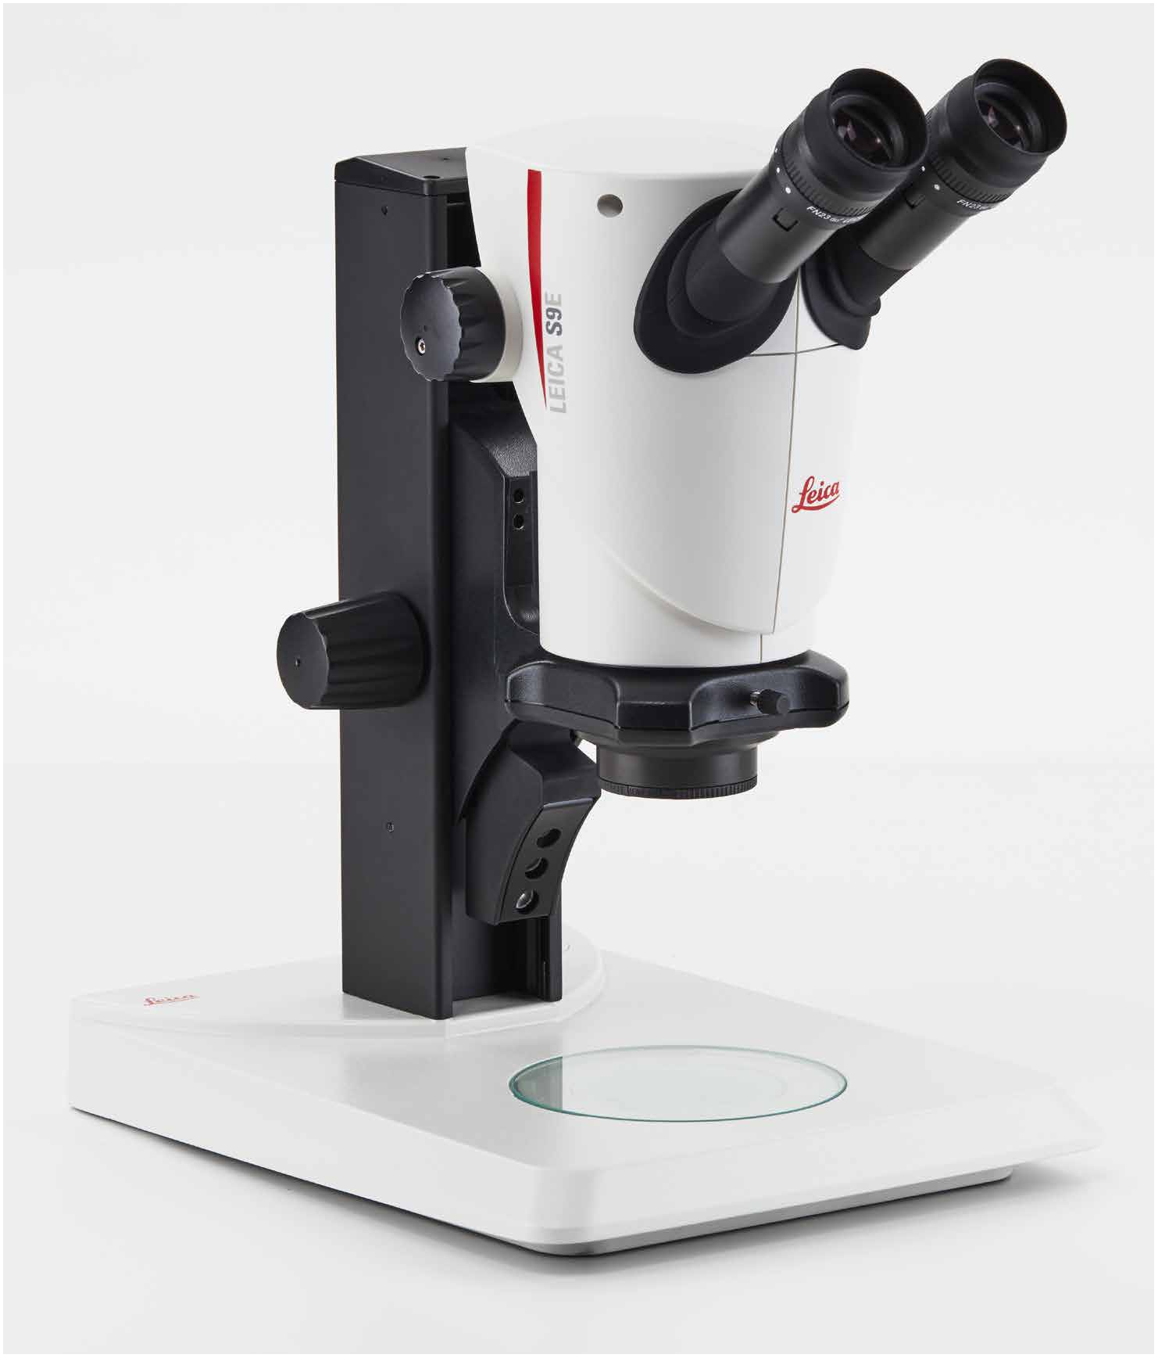

Leica S Series

S Series User Manual Leica S Series 10

