Overview
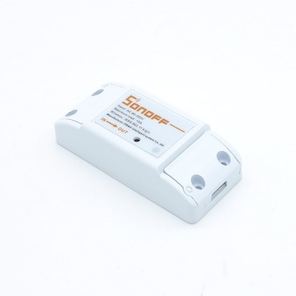
Home automation is "The Internet of Things". It simply means the way all devices or appliances are networked together to provide customers with a seamless control over their home equipment.
Sonoff is an affordable device that provides users with smart home control. It is a WiFi based wireless switch that can connect to a wide range of appliances. Sonoff transmits data to a cloud platform through the WiFi router, which enables users to remotely control all the connected appliances, via the mobile application eWeLink. The cloud server of Sonoff is Amazon AWS global server.
Sonoff makes all home appliances smart. As long as the mobile has network, users can remotely control the appliances from anywhere at any time. Another feature available is to set timing schedules for the appliances, which can include countdown, scheduled on/off, and can thus, help users maintain an easy life. Note: this Sonoff version does not have 433Mhz RF remote function.
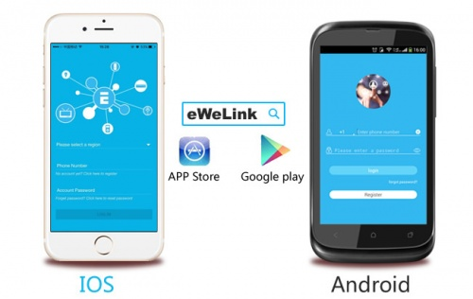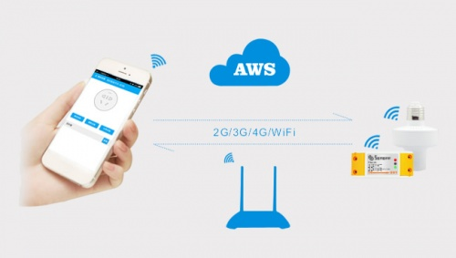
You can download the APP eWeLink in Apple App Store for iOS version and in Google Play for Android version.

Features
- Supports status tracking, home appliances status timely feedback to your App.
- Supports remotely turn on or off added devices.
- Supports single/repeat/countdown timing tasks for each added device.
- Supports numerous WiFi smart switches one account.
- Easy installation, easy handling and can be activated immediately and stably.

Specification
- Voltage range: 90-250v AC(50/60Hz)
- Max current: 10A
- Max Wattage: 2200 watts
- Dimensions: (L)88*(W)38*(H)23mm
- Color: White
- Operating Temperature: 0ºC-40ºC(32°F-104°F)
- Operating Humidity: 5%-90%RH, Non-condensing
- Wireless Frequency: 2.4Ghz

Hardware
